**Christopher King**

**2018141521058**

**Mechanical Design 2**

**Class Section 01**

**11/28/2021**

# **Problem 1**

Draw the internal and external thread profiles of a ¼ -20 – UNC thread and identify the key dimensions.



**Solution:**

Nominal major diameter of 0.25 in and 20 threads per inch.

Tensile Stress Area: .

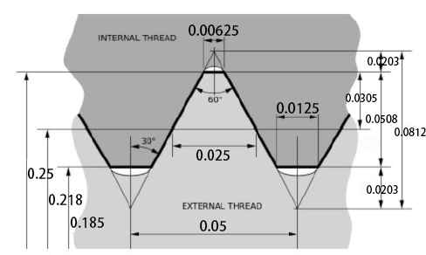

# **Problem 2**

An M14X2 hex-head bolt with a nut is used to clamp together two 15-mm steel plates.

1. Select a proper class R washer for the bolt and nut.
2. Determine a suitable length of the bolt, rounded up to the nearest 5 mm.
3. Determine the bolt stiffness.
4. Determine the stiffness of the member per Eq. 8-19.
5. Repeat (c) using Eq. 8-22 and Eq. 8-23.

**Solution:**

Nominal major diameter of 14 mm and pitch of 2 mm.

Therefore, I select washer size from Table A-33 with maximum thickness .

From Table A-31, the nut height is .

Hence,

Rounded up to the nearest 5 mm,

The thread length of inch-series bolts is

Length of unthreaded portion in grip:

Length of threaded portion in grip:

Area of unthreaded portion:

Area of threaded portion (from Table 8-1):

Fastener stiffness:

Eq. 8-19: the spring rate or stiffness of upper frustum

Eq. 8-19: the spring rate or stiffness of middle frustum

Eq. 8-19: the spring rate or stiffness of lower frustum

Total member stiffness:

Eq. 8-22:

Eq. 8-23:

(Table 8-8 (Steel): , )

# **Problem 3**

A **30-mm** thick AISI 1020 steel plate is sandwiched between a **10-mm** thick 2024-T3 aluminum plate on the top and another **20-mm** thick 2024-T3 aluminum plate on the bottom. The plates are tightened with a bolt and nut as well as washers of class N under both. The bolt is M10 × 1.5, property class 5.8.

1. Assuming the bolt requires its length to be at least 2 threads beyond the nut after tightening. Determine the minimum length of the bolts per Table A-17.
2. Determine the bolt stiffness.
3. Determine the stiffness of the members using Eq. 8-20.
4. Determine the stiffness of the joint.

**Solution:**

Nominal diameter of bolt is .

Therefore, I select washer size from Table A-33 with maximum thickness .

From Table A-31, the nut height is .

Hence,

The minimum length of the bolts per Table A-17 is equal to

The thread length of inch-series bolts is (Table 8-7)

Length of unthreaded portion in grip:

Length of threaded portion in grip:

Area of unthreaded portion:

Area of threaded portion (from Table 8-1):

Fastener stiffness:

Eq. 8-20: the spring rate or stiffness of upper aluminum frustum

Eq. 8-20: the spring rate or stiffness of upper steel frustum

Eq. 8-20: the spring rate or stiffness of lower steel frustum

Eq. 8-20: the spring rate or stiffness of upper aluminum frustum

Total member stiffness:

The joint stiffness is equal to

# **Problem 4**

Assuming the bolt requires its length to be at least 2 threads beyond its grip length. Repeat Prob. #3 (a) thru (d) with the bottom aluminum plate having a threaded hole to eliminate the nut.

**Solution:**

Nominal diameter of bolt is .

Therefore, I select washer size from Table A-33 with maximum thickness .

Hence,

The minimum length of the bolts per Table A-17 is equal to

The thread length of inch-series bolts is (Table 8-7)

Length of unthreaded portion in grip:

Length of threaded portion in grip:

Area of unthreaded portion:

Area of threaded portion (from Table 8-1):

Fastener stiffness:

Eq. 8-20: the spring rate or stiffness of upper aluminum frustum

Eq. 8-20: the spring rate or stiffness of upper steel frustum

Eq. 8-20: the spring rate or stiffness of lower steel frustum

Eq. 8-20: the spring rate or stiffness of upper aluminum frustum

Total member stiffness:

The joint stiffness is equal to